Method 1: JPG/PNG to OLED using image2cpp
Image to OLED
- Take an Image like panda.jpg
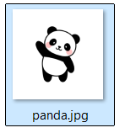
- Open this website https://javl.github.io/image2cpp/
- Upload Image here
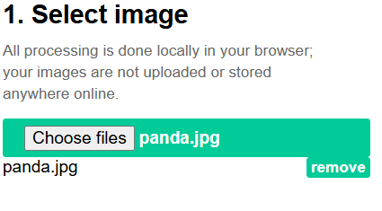
- Change Image properties from here
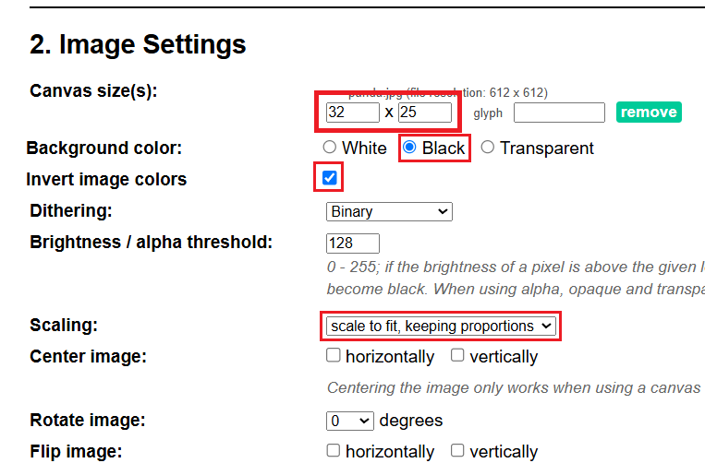
OR
- Here you can see the preview
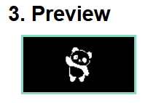
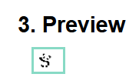
OR
- From here you can Generate & download the code
Another image2cpp Link: https://diyusthad.com/image-to-cpp-v2
- Output
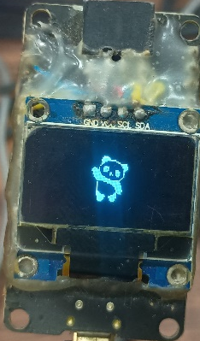
GIF Image to OLED:
- Open this website https://image.online-convert.com/convert/gif-to-jpg
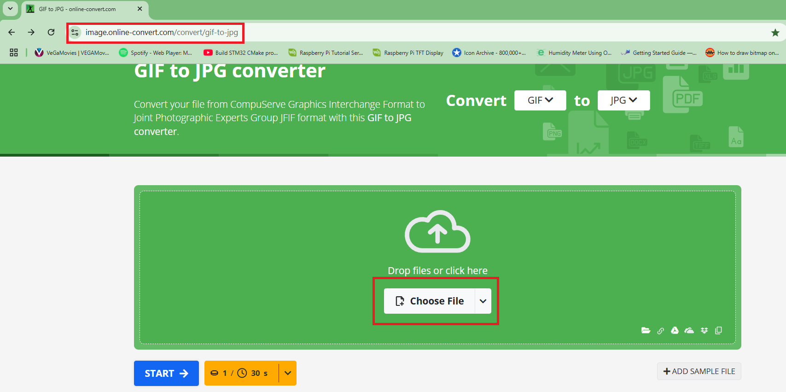
Tutorial Link: https://github.com/upiir/arduino_oled_animations
Download Animations Link: https://animator.wokwi.com/
- Drop here a gif image & convert into jpg
- Then download images in a zip file
- Open this website https://javl.github.io/image2cpp/
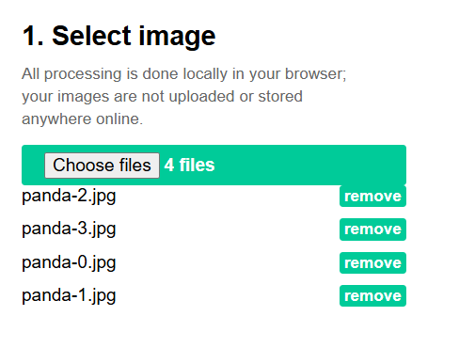
- Then change the pixel setting to 128x64 and download the code
Method 2: JPG/PNG to OLED using LCDAssistant
- Take an Image like panda.jpg and open with Paint.
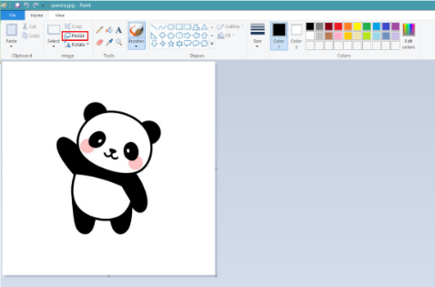
- Resize this image to 128x64 because this software has a bug that only support it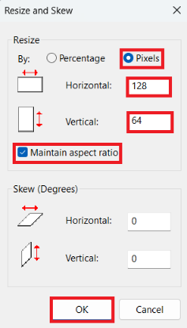
- Now save the resized image as “bmp” format
Tutorial Link: https://miliohm.com/how-to-draw-or-print-bitmap-to-oled-display-arduino/
- Save Image as “monochrome” bitmap format
- Now open “LCDAssistant.exe” and load an Image file
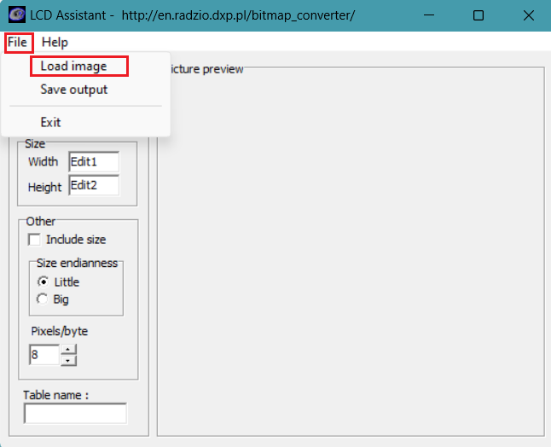
- Then set Byte orientation to Horizontal & size must be 128x64 & save the output
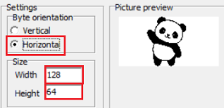
Method 3: JPG/PNG to OLED using lcd-image-converter
- Take an Image like panda.jpg and open with Paint.
- Resize this image to as per your requirement make sure the height is 64 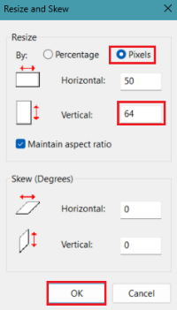
Tutorial Link: https://www.hackster.io/Arnov_Sharma_makes/displaying-your-own-photo-on-oled-display-5a8e8b
- Now open “lcd-image-converter.exe” and open an Image file
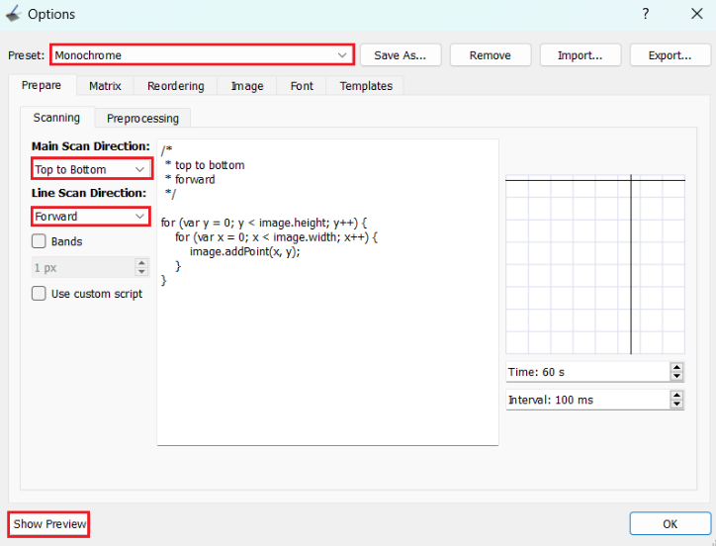
- Then copy the array & paste in your code

Method 4: Graphics Design using lopaka
- Open this website & create a new project https://lopaka.app/
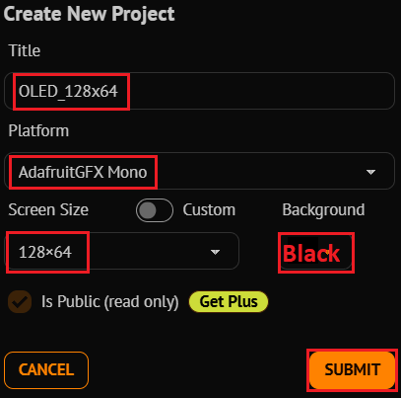

- Then Design what ever you want & then copy the code
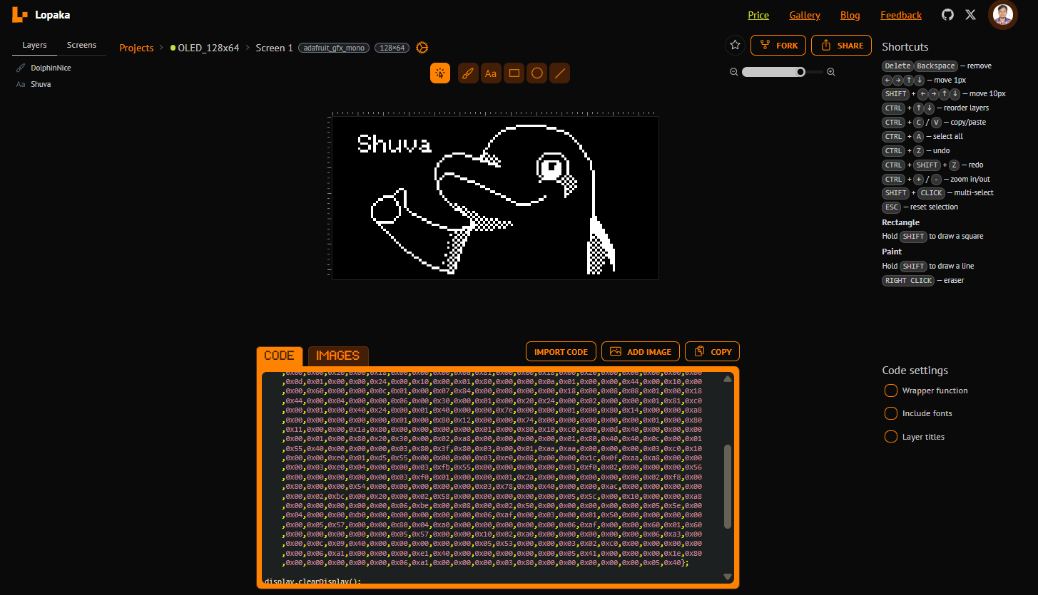
Other Links
- Bulk Image Resizer: https://redketchup.io/bulk-image-resizer
- Online Photo Editor Software (like photoshop): https://www.photopea.com/ or https://www.piskelapp.com/
- Animation or Icons Download: https://www.iconarchive.com/ or https://icons8.com/icons/set/popular--animated
- Resize or Crop Animated GIFs: https://www.iloveimg.com/ or https://ezgif.com/crop
- PNG Image Transparent Background: https://onlinepngtools.com/create-transparent-png

